Firmware is a special type of software that’s permanently stored inside hardware devices (like your computer’s motherboard, phone, or router) to help them function correctly.
Let’s break it down simply 👇

💡 Definition:
Firmware is low-level software embedded into a hardware device that provides the necessary instructions for how the device should communicate with other hardware and software.
It acts as a bridge between hardware and higher-level software (like an operating system).

🧠 Example:
When you power on your computer:
- The BIOS or UEFI firmware starts first.
- It checks your hardware (CPU, RAM, storage, etc.).
- Then it loads the bootloader → which then loads the operating system (like Linux or Windows).
So, without firmware, your hardware wouldn’t even know how to start working!

⚙️ Where firmware is used:
- Motherboard: BIOS/UEFI firmware
- Phones: Embedded firmware controlling touch, battery, and camera
- Routers: Firmware controls network routing
- Smart TVs, printers, SSDs, mice, and keyboards — all have firmware inside!

🧩 Types of Firmware:
Type | Description
Low-level firmware | Stored in ROM, rarely updated. Example: basic boot firmware in old devices.
High-level firmware | Stored in flash memory, can be updated (e.g., phone firmware updates).
Subsystem firmware | Controls specific parts like Wi-Fi cards or hard drives.

🔁 Firmware Update:
Manufacturers often release firmware updates to:
- Fix bugs 🐞
- Improve performance ⚡
- Add new features 🔧
- Patch security vulnerabilities 🔐
Example: Updating router firmware to improve Wi-Fi stability.

🧩 Summary:
Feature | Firmware
Stored in | ROM / Flash Memory
Role | Controls hardware behavior
Level | Between hardware and OS
Updateable | Yes (in modern devices)
Example | BIOS/UEFI, router software, phone baseband

🧠 1. BIOS and UEFI — The Firmware Types

🔹 BIOS (Basic Input/Output System)
- Old, traditional firmware used before UEFI.
- Stored on the motherboard chip.
- Text-based interface (no mouse, only keyboard).
- Runs a process called POST (Power-On Self Test) — checks CPU, RAM, storage.
- Then it looks for a bootloader in the MBR of the storage device.
- Can only boot from drives ≤ 2 TB and supports only 4 primary partitions.
📺 Interface: Text-based
🗂 Boot mode: MBR (Master Boot Record)

🔹 UEFI (Unified Extensible Firmware Interface)
- Modern replacement for BIOS.
- Faster, more secure, and supports larger disks.
- Uses GPT (GUID Partition Table) instead of MBR.
- Has a graphical interface (GUI) – you can use a mouse.
- Supports Secure Boot, Network Boot, and Boot Manager.
- Can read FAT32 partitions directly (thanks to the EFI System Partition).
📺 Interface: GUI (Graphical User Interface)
🗂 Boot mode: GPT (GUID Partition Table)

💽 2. MBR (Master Boot Record)
- The first 512 bytes of a storage device.
- Contains:
  - Bootloader (small code that starts the OS loading)
  - Partition Table (info about disk partitions)
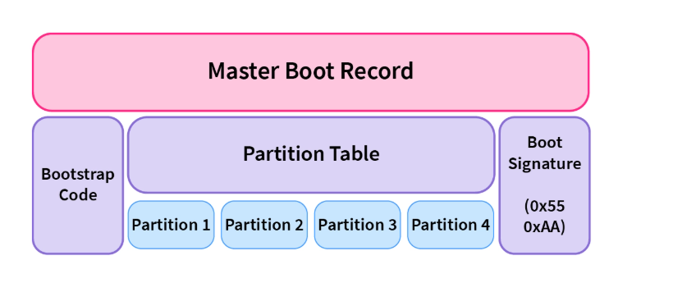
- BIOS firmware reads MBR → loads bootloader → bootloader loads OS.
⚠️ Limitations:
- Maximum disk size: 2 TB
- Maximum 4 primary partitions
- If MBR is corrupted, system won’t boot.

💿 3. GPT (GUID Partition Table)
- Used with UEFI firmware.
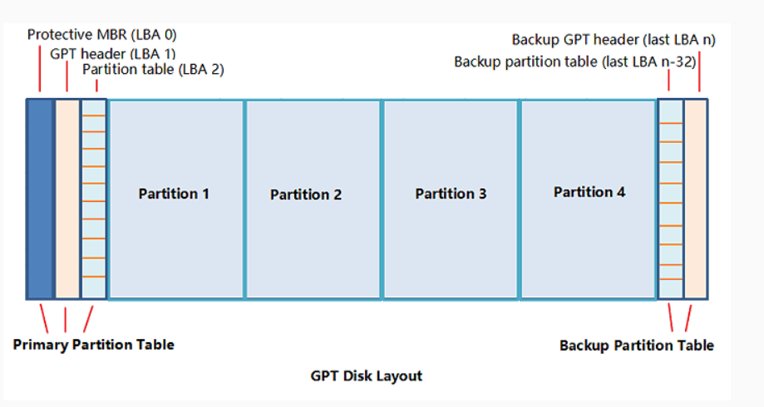
- More advanced and reliable than MBR.

🧩 GPT Features:
- Supports disks larger than 2 TB.
- Allows up to 128 partitions.
- Stores multiple copies (redundancy) of the partition table across the disk for recovery.
- Each partition has a unique GUID (Globally Unique Identifier).

🔐 Protective MBR (in GPT disks):
Even GPT disks contain a tiny Protective MBR at the beginning.
👉 Its purpose: to protect GPT data from old BIOS tools that only understand MBR.
Those old tools will see one big partition instead of thinking the disk is empty.

⚙️ 4. ESP (EFI System Partition)
- A small FAT32 partition (usually 100–500 MB) created on GPT disks.
- Stores:
  - Bootloaders (like GRUB, Windows Boot Manager)
  - Device drivers
  - UEFI applications (like diagnostics tools)
- UEFI firmware reads the bootloader directly from the ESP to start the OS.
📂 Typical path (Linux): /boot/efi
📂 Typical path (Windows): EFI/Microsoft/Boot/bootmgfw.efi

🧩 5. BIOS vs UEFI — Quick Comparison
Feature | BIOS | UEFI
Interface | Text-based | GUI (Graphical)
Disk type | MBR | GPT
Bootloader location | MBR | EFI System Partition
Max partition support | 4 primary | 128 partitions
Disk size limit | 2 TB | 9.4 ZB (virtually unlimited)
Security | Basic | Secure Boot, faster startup
Redundancy | None | GPT keeps backup tables

✅ In summary:
- BIOS = old firmware using MBR
- UEFI = modern firmware using GPT
- Bootloader = small code that starts OS
- Partition Table = map of disk partitions
- Protective MBR = protects GPT disks from old software
- ESP = partition where UEFI stores boot files
- GUI vs Text-based = BIOS is text-only, UEFI has a graphical mouse-friendly interface

